**Day 8- JavaScript**

https://lh6.googleusercontent.com/pzfkpYzj_xNKuCIRaMdGOcJRGHimowNa5u7Ned4rI9rrL8AGediPxVgoTzYM65B3F7T2wKnzzs4NN42aMrsGf_ZZvSDkx9V2RHZ5SJ6YjjldEA7E9x9SwUSXZmLWBKV9rfHuNRbkG3bXpFexSg

**Refresh yesterday’s Class-10 Minutes**

1. Which of the following is used to sets an icon inside the input?
2. background-image: search.jpg;
3. background-image: url=”search.jpg”;
4. background-image: url('search.jpg');

1. What is the use of padding property Input fields?
2. add space inside the text field
3. add space between the text field
4. add space outside the text field
5. If you only want to style a text input type, which of the following is used?
6. input[type=text]{ }
7. input[type=”text”]{ }
8. input{ }

**Activity- 10 Minutes**

<!DOCTYPE html>

<html>

<body>

<p id="demo"></p>

<script>

document.getElementById("demo").innerHTML = "Hello JavaScript!";

</script>

</body>

</html>

**Activity- 20 Minutes**

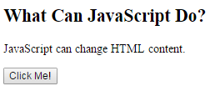

<!DOCTYPE html>

<html>

<body>

<h2>What Can JavaScript Do?</h2>

<p id="demo">JavaScript can change HTML content.</p>

<button type="button" onclick='document.getElementById("demo").innerHTML = "Hello JavaScript!"'>Click Me!</button>

</body>

</html>

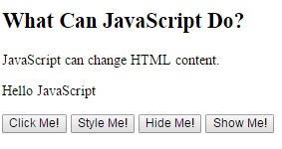

<!DOCTYPE html>

<html>

<body>

<h2>What Can JavaScript Do?</h2>

<p id="demo">JavaScript can change HTML content.</p>

<p id="demo1">Hello JavaScript</p>

<button type="button" onclick='document.getElementById("demo").innerHTML = "Hello World!"'>Click Me!</button>

<button type="button" onclick="document.getElementById('demo1').style.fontSize='35px'">Style Me!</button>

<button type="button" onclick="document.getElementById('demo1').style.display='none'">Hide Me!</button>

<button type="button" onclick="document.getElementById('demo1').style.display='block'">Show Me!</button>

</body>

</html>

**JavaScript Outputs-30 Minutes**

<!DOCTYPE html>

<html>

<body>

<p id="demo"></p>

<script>

document.getElementById("demo").innerHTML = 5 + 6;

</script>

</body>

</html>

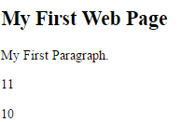

<!DOCTYPE html>

<html>

<body>

<p id="demo"></p>

<script>

document.getElementById("demo").innerHTML = 5 + 6;

document.write(5 + 5);

</script>

</body>

</html>

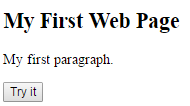

<!DOCTYPE html>

<html>

<body>

<h2>My First Web Page</h2>

<p>My first paragraph.</p>

<button type="button" onclick="document.write(15 + 6)">Try it</button>

</body>

</html>

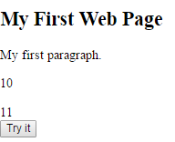

<!DOCTYPE html>

<html>

<body>

<h2>My First Web Page</h2>

<p>My first paragraph.</p>

<p id="demo"></p>

<script>

document.write(5 + 6);

document.getElementById("demo").innerHTML = 5 + 5;

window.alert(1 + 6);

window.alert("Welcome");

</script>

<br>

<button type="button" onclick="document.write(15 + 6)">Try it</button>

</body>

</html>

**JavaScript-Placement in HTML file-30 Minutes**

<!DOCTYPE html>

<html>

<head>

<script type="text/javascript">

function sayHello() {

alert("Hello World")

}

</script>

</head>

<body>

<input type="button" onclick="sayHello()" value="Say Hello" />

</body>

</html>

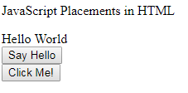

**Javascript.html**

<html>

<head>

<script type="text/javascript" src="file.js" ></script>

<script type="text/javascript">

function sayHello()

{

alert("Hello World");

}

</script>

</head>

<body>

<p id="demo"></p>

<script type="text/javascript">

document.write("Hello World")

document.getElementById("demo").innerHTML = "JavaScript Placements in HTML";

</script>

<br>

<input type="button" onclick="sayHello()" value="Say Hello" />

<br>

<input type="button" onclick="helloJavaScript()" value="Click Me!" />

</body>

</html>

**file.js**

function helloJavaScript() {

alert("Hello JavaScript.................")

document.write("Hai World...");

}